Lab 04
4 | Digital Signaling & Gnu Radio
 | Advanced Wireless Lab
TLEN 5830
Advanced Wireless Systems

Lab 4
Open GNU Radio Companion
- You can open using a terminal/console
- On Terminal search for ‘grc’
- On console run ‘gnuradio-companion’

The general outlay of a GNU Radio project
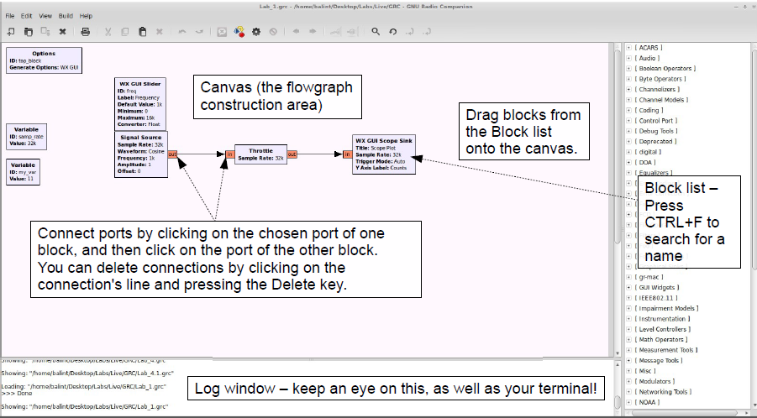

Optional Block - Used to set global parameters
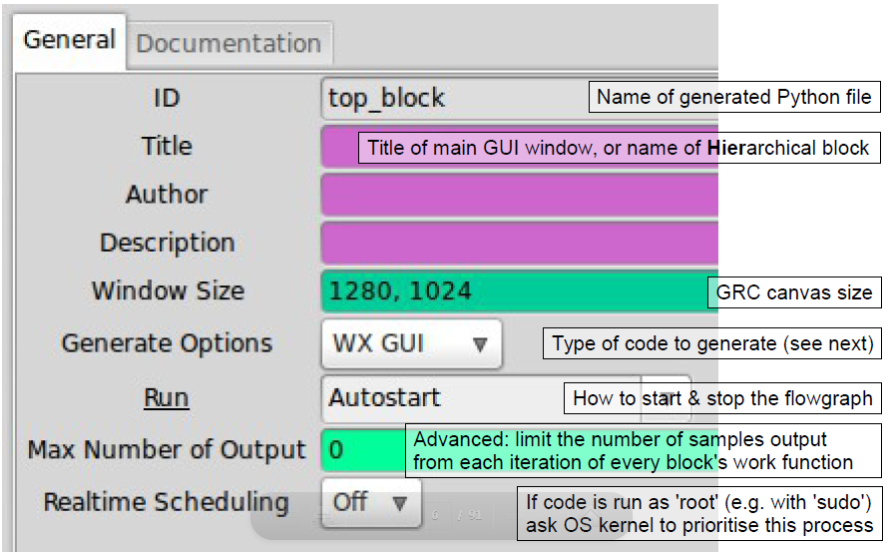
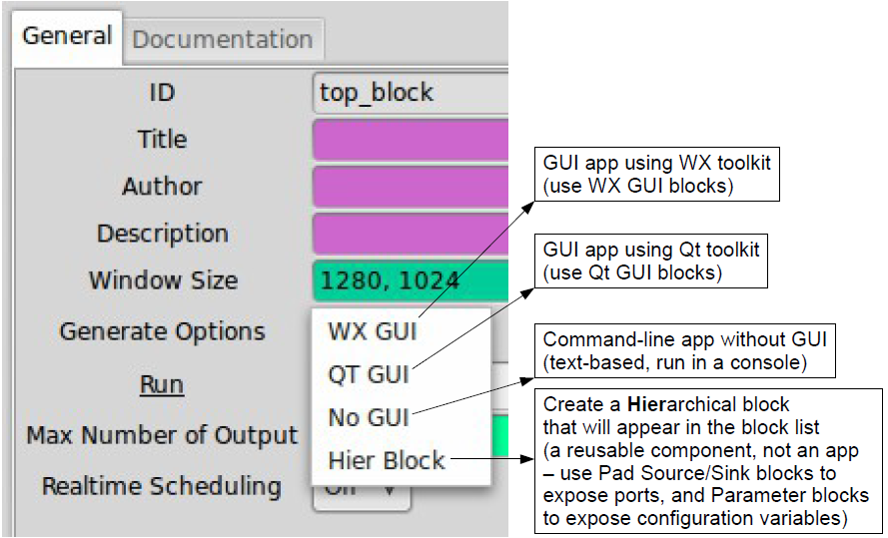

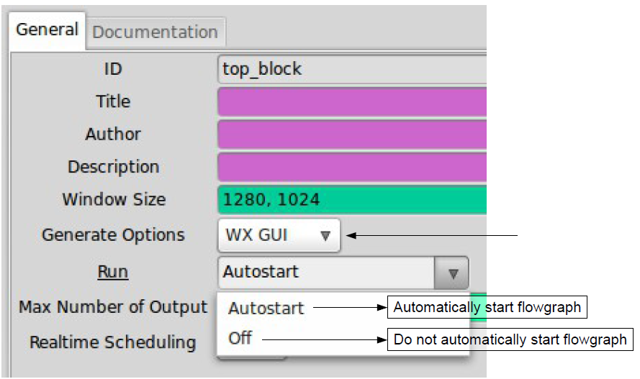
Note: On selecting ‘QT GUI’ in generate options field, you can see an additional field QSS theme. QSS (Qt Style sheets) are useful to customize the appearance of widgets. The application is similar to CSS implemented in designing websites.
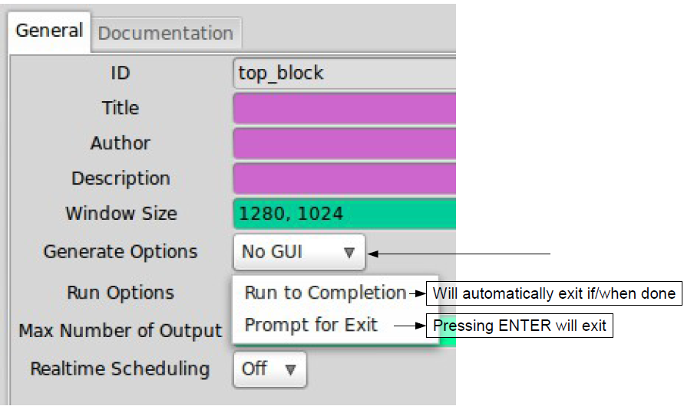
Variable – A block that contains an arbitrary Python expression. Each variable can be identified and refered by ID field. The ‘samp_rate’ variable is present by default in a new project.

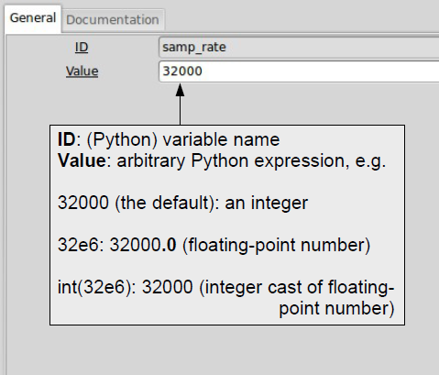

Example 1: creating a sine wave and observing the signal in a scope
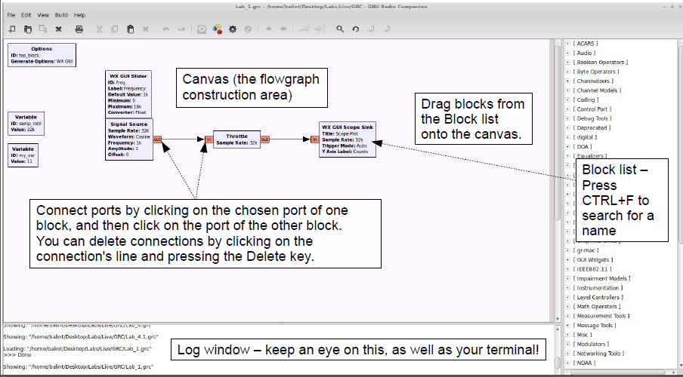

General functions of each block.
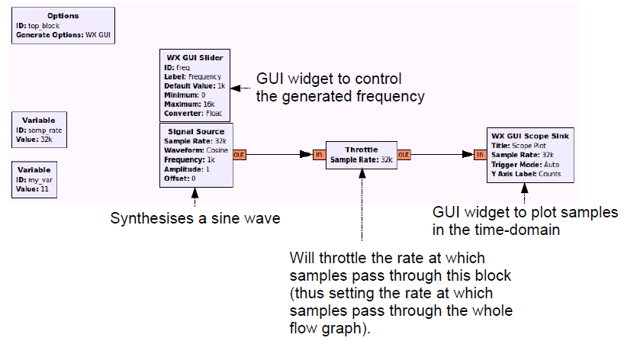

The parameters are defined in the blocks as below
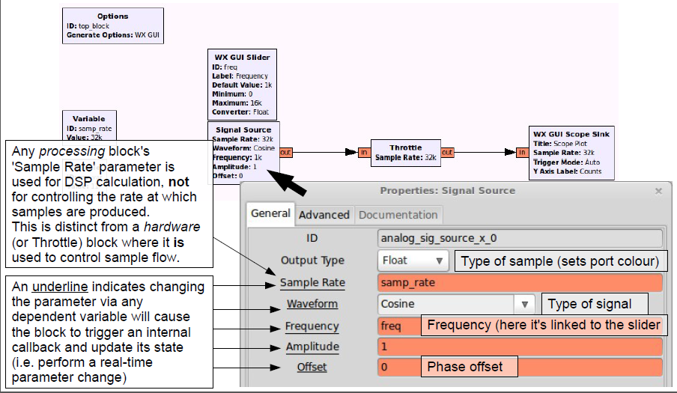
In the above block, the frequency is a variable and can be controlled by a slider, while the amplitude is fixed.
Note: The input/output port color indicates the type of samples. The type/color can be changed by single-clinking the block and press the up/down arrows.

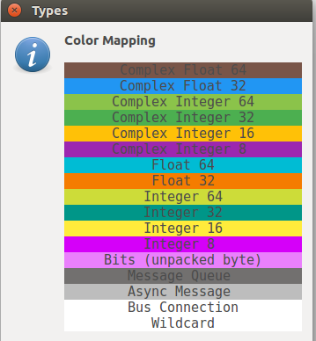
The properties of the slider and throttle blocks are similar to signal source block. The properties of scope block are depicted in the below figure.
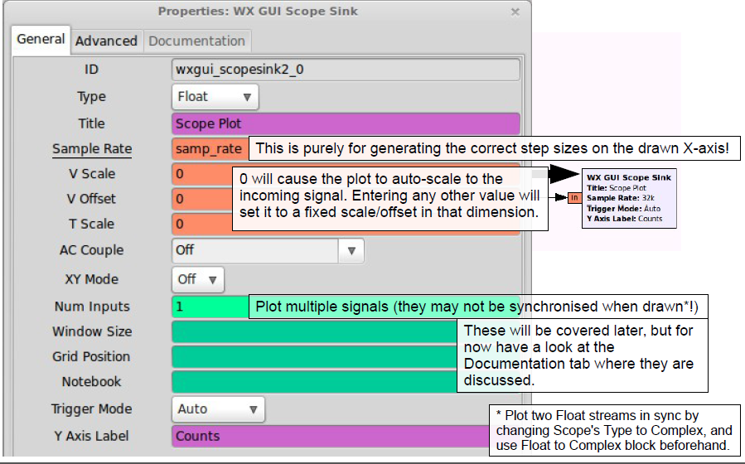

Note: Possible error scenarios
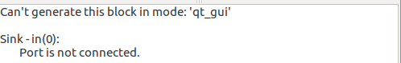
Make sure the blocks are of the same mode which you selected in the ‘generate options’ of the Options block. To run the project, you must make sure that all the input and output ports are connected. You can disable a block by selecting the block and pressing ‘D’ and enable it by pressing ‘E’. Make sure the ports are connected to similar type and in the block list you can find data type converters if necessary.
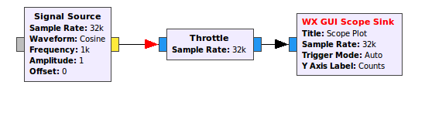

To control the parameters in the output scope.
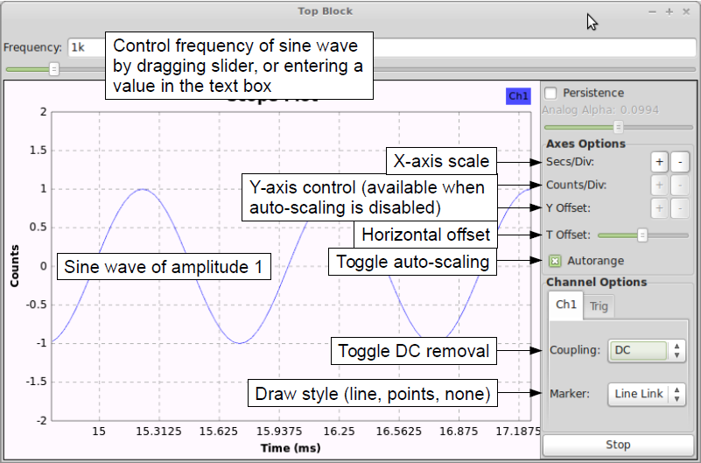

Some other output blocks of interest are FFT sink and waterfall sink (parameters of both are identical)
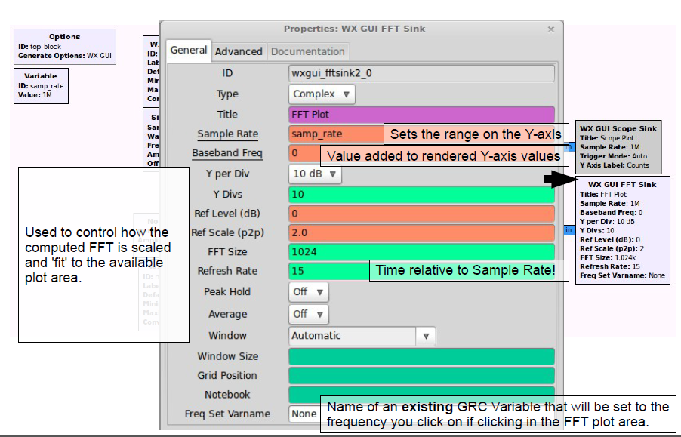
One another feature is Notebook which can integrate multiple output sinks in a single tab.
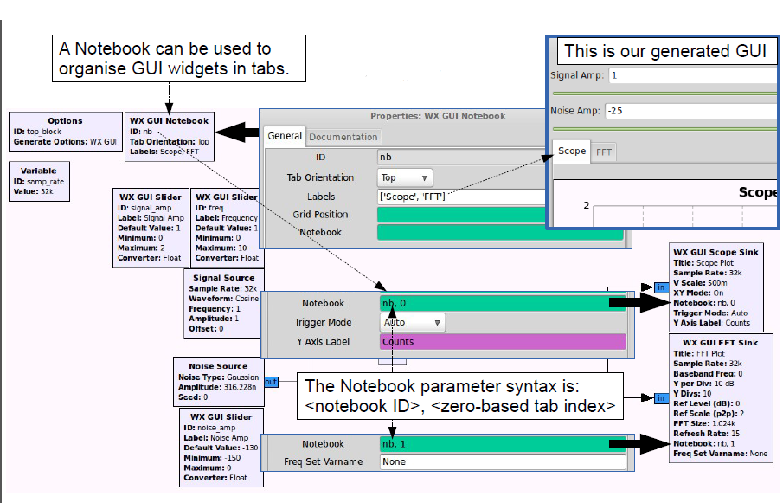

Example 2: Audio Sink
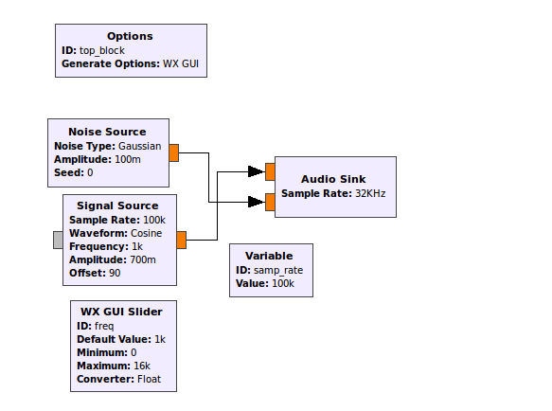

Change the sampling rate and observe different tones.
Ques: What is the use of the Throttle block? When do you need to have the block in a project? Explain.

Objectives:
- Design a BPSK, QPSK, and QAM modulation project.
  - Paste screenshots of the project workspace and constellation diagram.
  - Explain the properties/fields of the modulator block.
  - Explain the use of excess bandwidth.
- Create new blocks with the help of python, XML, and gr_modtool.
  - multiply block
  - QPSK demodulation block
Note: You can look up the steps for creation of new blocks in the following link. The objective 2 requires knowledge of basic linux commands.
  - Demodulate a Noise Source signal (type: gaussian) with the help of QPSK Demodulation Block and paste the screenshot of the same.
http://gnuradio.org/redmine/projects/gnuradio/wiki/Guided_Tutorial_GNU_Radio_in_Python

