|  |  |
| --- | --- |
| Pre-Lab 02 |  |
| *2* | *AM, DSB-SC, FDM* |
|  | **Advanced Wireless Lab** |
| TLEN 5830 |  |
| Advanced Wireless Systems |  |

**Amplitude Modulation**

The basis for analog signaling is a continuous constant-frequency signal known as the carrier signal:

* The frequency of the carrier signal is chosen to be compatible with the transmission medium
* In the case of wireless communications, frequencies must also be used as specified by regulatory agencies
* Data (information) may be transmitted using a carrier signal by the process of **modulation**

Modulation is the process of encoding source data onto a carrier signal with frequency *f*c. All modulation techniques involve sending information by changing one or more of the three fundamental frequency domain parameters: amplitude, frequency, phase.

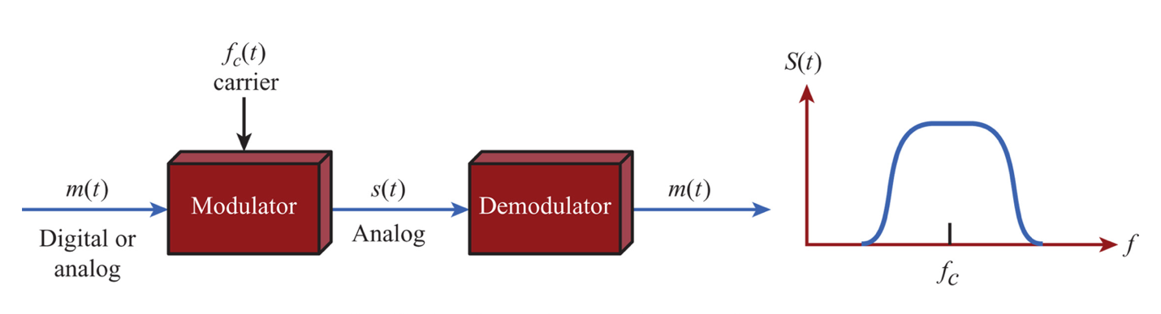

**Figure 1 - Modulation onto an analog signal**

The input signal *m(t)* may be analog or digital and is called the modulating or baseband signal. The result of the modulating the carrier signal is called the modulated signal *s(t)*. *s(t)* is a bandlimited (bandpass) signal. The location of the bandwidth on the spectrum is related to *f*c and is often (usually) centered on *f*c.

Amplitude Modulation



Where,

* + - cos2π*fct* = carrier
    - *x(t)* = input signal (Note: *m(t)* in Figure 1 above)
    - *na* = modulation index: Ratio of amplitude of input signal to carrier

The above formulation is commonly referred to as double sideband transmitted carrier, DSBTC. Note that the carrier signal and the input signal in the above equation are normalized to unity amplitude.

Essentially an amplitude modulated wave consists of a radio frequency carrier - a sine wave at one frequency, typically in the radio frequency portion of the spectrum. A modulating wave, which in theory could be another sine wave, typically at a lower frequency is superimposed upon the carrier.

The equation for the overall modulated signal is obtained by multiplying the carrier and the modulating signal together.

**DSB-SC**

Double-sideband suppressed-carrier transmission (DSB-SC) is transmission in which frequencies produced by amplitude modulation (AM) are symmetrically spaced above and below the carrier frequency and the carrier level is reduced to the lowest practical level, ideally being completely suppressed. (Hint: keep A=0 to get the DSB-SC signal from the AM signal)

**LabVIEW template**

Please use the template given below to generate an AM signal and DSB-SC signal. (note: the NI USRP blocks are for interfacing USRP with LabVIEW. For pre-lab, complete the connections required to generate the AM signal and do not worry about interfacing USRP)

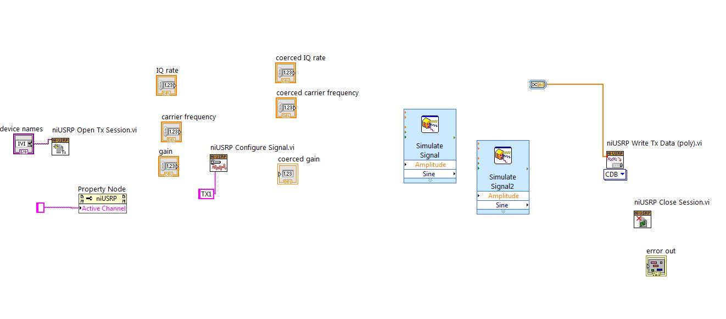

**DSB-SC**

Double-sideband suppressed-carrier transmission (DSB-SC) is transmission in which frequencies produced by amplitude modulation (AM) are symmetrically spaced above and below the carrier frequency and the carrier level is reduced to the lowest practical level, ideally being completely suppressed.

(hint: keep A=0 to get the DSB-SC signal from the AM signal)

**FDM**

Frequency-division multiplexing (FDM) is a scheme in which numerous signals are combined for transmission on a single communications line or channel. Each signal is assigned a different frequency (sub channel) within the main channel.

**LabVIEW template**

Please use the template given below to simulate FDM. (note: do not worry about interfacing USRP for pre-lab)

