Pre-Lab 03
2 | Eye Diagram
 | Advanced Wireless Lab
TLEN 5830
Advanced Wireless Systems

EYE DIAGRAM:
It is a way of evaluating the quality of the received digital waveform. Quality here means that the ability to correctly recover symbols and timing. The eye diagram reveals the impact of ISI and noise.
The following link gives more information regarding eye diagram in case you want to explore further.
http://www.onsemi.com/pub_link/Collateral/AND9075-D.PDF

Interpretation of eye diagram:
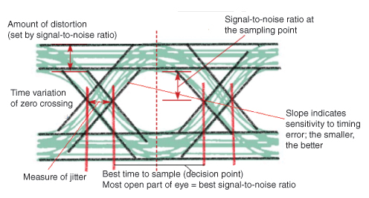

Setup:
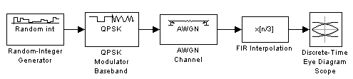
The above diagram was implemented in LabVIEW to get the eye diagram.
Random integer is used to generate a random number between 0 – 3, which is then input to the case structure in LabVIEW. The case structure is used to generate 4 signals with different phases (check the vi file) for QPSK modulation.
Q1) What is the role of FIR interpolation in the generation of eye diagram? Can the pattern be generated without it?
Q2) The receiver vi file contains the AWGN block. Check the output pattern with and without the AWGN block.
Note: you will be given the template vi file for both transmission and reception. For prelab, combine the transmission and reception vi into a single file so that the pattern can be checked. For lab, the VIs need to be in separate files to interface with USRP. Do not worry about interfacing with the USRP hardware yet. Complete the connection and check if you are able to display the pattern on the waveform graph.

NOTE - The provided VIs can be run only on LabVIEW Communication Suite 2.0

