Pre-Lab 05
5 | OFDM using GNU Radio and MATLAB
 | Advanced Wireless Lab
TLEN 5830
Advanced Wireless Lab

OFDM

OFDM is a frequency-division multiplexing (FDM) scheme used as a digital multi-carrier modulation method. A large number of closely spaced orthogonal sub-carrier signals are used to carry data^{[1]} on several parallel data streams or channels.

Each sub-carrier is modulated with a conventional modulation scheme (such as quadrature amplitude modulation or phase-shift keying) at a low symbol rate, maintaining total data rates similar to conventional single-carrier modulation schemes.

The primary advantage of OFDM over single-carrier schemes is its ability to cope with severe channel conditions (for example, attenuation of high frequencies in a long copper wire, narrowband interference and frequency-selective fading due to multipath) without complex equalization filters.

OFDM Block Diagram

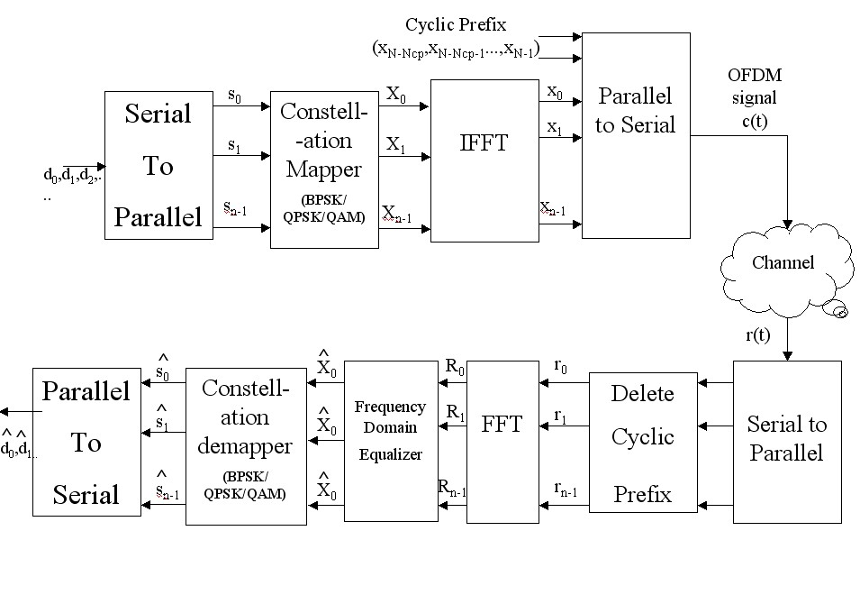
- The incoming serial data is first converted from serial to parallel and grouped into x bits each to form a complex number.

- The complex numbers are modulated in a baseband fashion by the IFFT and converted back to serial data for transmission.

- The receiver performs the inverse process of the transmitter. Equalizer is used to correct channel distortion.

GNU Radio

Implement OFDM transmitter and receiver using GNU Radio. Interfacing with USRP is not required for the pre-lab activity.

MATLAB

MATLAB is an iterative tool for performing numerical calculations. This is also a great tool for solving algebraic and differential equations and for numerical integration. MATLAB has powerful graphic tools and can produce nice pictures in both 2D and 3D. It is also a programming language, and is one of the easiest programming languages for writing mathematical programs. MATLAB also has some tool boxes useful for signal processing, image processing, optimization, etc.

Upon launching MATLAB, there is a Command Window and an Editor. Editor is used for the writing the codes and Command window is used to display the errors or the output of the code. Commands can also be entered to the Command Editor to perform few trivial tasks.

For example, typing “a = 2*2” in the CW prints 4.
Typing “help help “in the CW gives a brief synopsis of the help system.

When in doubt about a command, type “help command-name” in CW or search the MatLab help document.
MATLAB also supports model-based design using Simulink. For this lab, kindly use the Editor for programming and for subsequent labs, we would be using Simulink.

OFDM Transmitter using MATLAB:

For simulating OFDM Transmitter using MATLAB, interfacing with USRP is not required for this lab. This lab emphasizes the implementation of the OFDM concept including different application frameworks (e.g., Gnu Radio, MatLab, LabView, etc.) that support OFDM experimentation.

The below commands can be of assistance to start with:
- stem()
- subplot()
- randsrc()
- reshape()

